Hands on 1: Create a Spring Web Project using Maven

1.Go to https://start.spring.io/
2. Change Group as “com.cognizant”
3. Change Artifact Id as “spring-dn”
4. Select Spring Boot DevTools and Spring Web
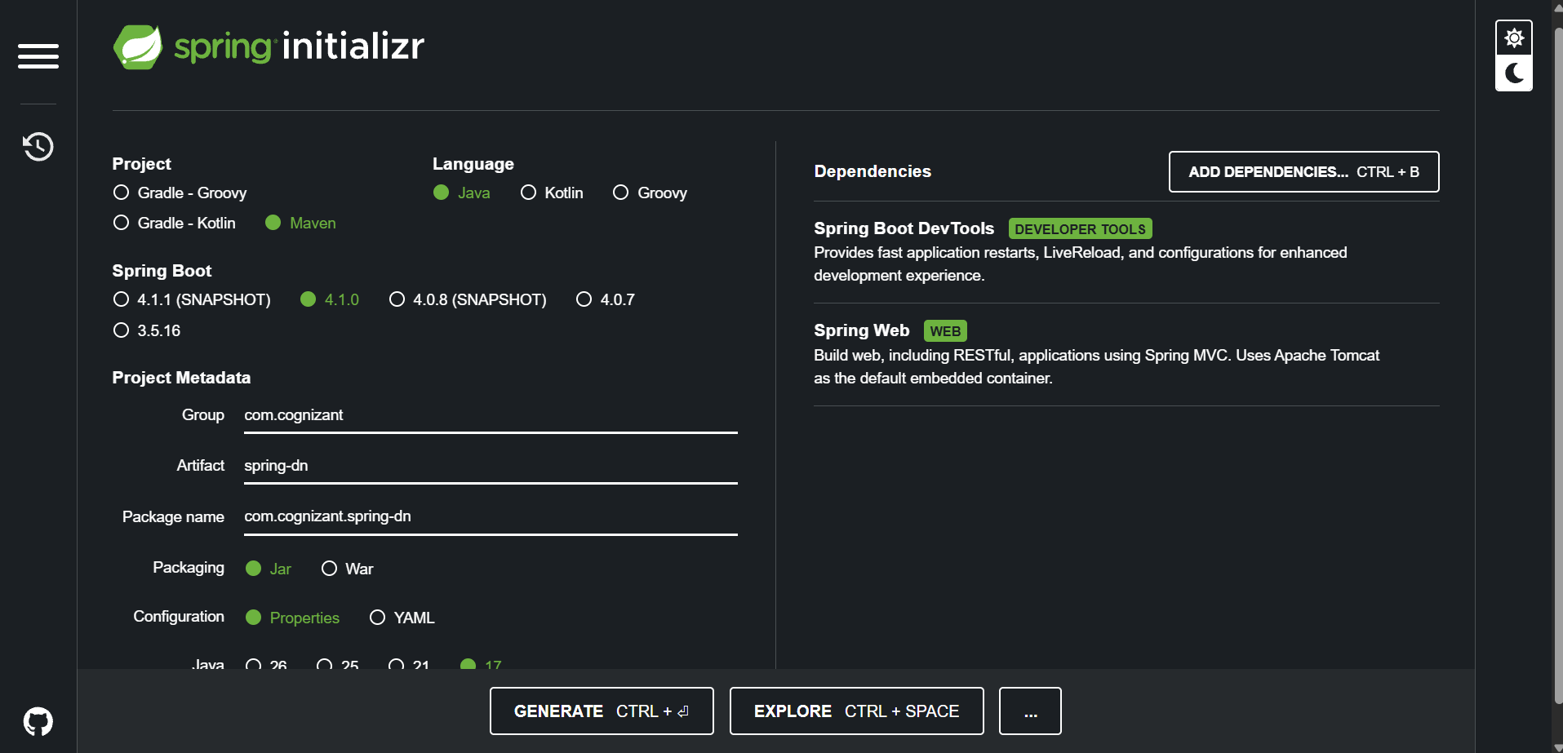
5. Create and download the project as zip
6. Extract the zip in root folder to Visual Studio Code Workspace
7. Build the project using ‘mvn clean package –
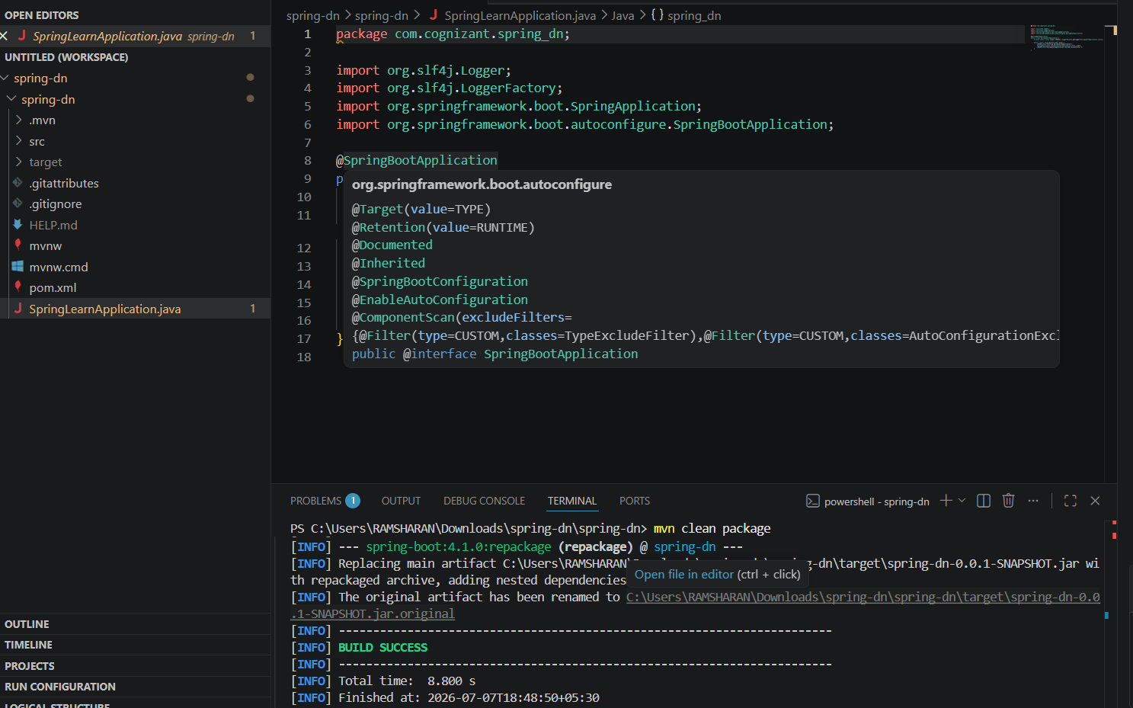
9. Include logs to verify if main() method of SpringLearnApplication.
SpringLearnApplication.java:
package com.cognizant.spring_dn;

import org.slf4j.Logger;
import org.slf4j.LoggerFactory;
import org.springframework.boot.SpringApplication;
import org.springframework.boot.autoconfigure.SpringBootApplication;

@SpringBootApplication
public class SpringLearnApplication {
private static final Logger LOGGER = LoggerFactory.getLogger(SpringLearnApplication.class);

public static void main(String[] args) {
LOGGER.info("Starting SpringLearnApplication");
SpringApplication.run(SpringLearnApplication.class, args);
LOGGER.info("SpringLearnApplication started successfully.");
}
}

10. Run the SpringLearnApplication class.
